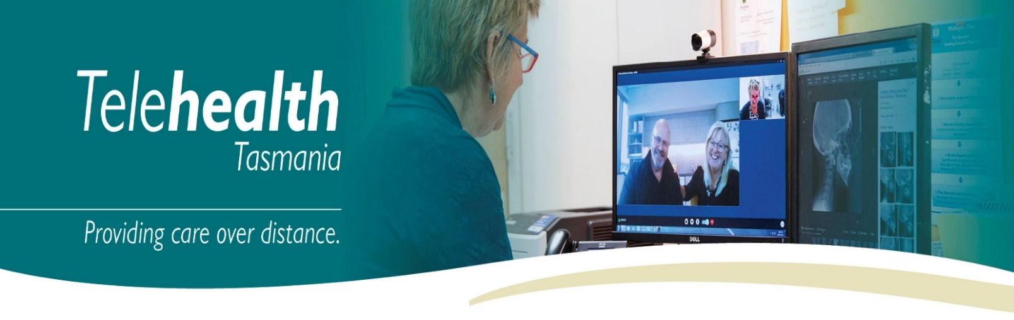
Telehealth with Chrome, Firefox, Edge and Opera
(PC, MAC, Laptops)

Overview
Telehealth Tasmania provides an easy, safe and secure way to videoconference with your clinician from any PC, MAC or laptop.

Requirements
- PC, MAC or laptop with a webcam, microphone and speakers. You may also prefer to use headphones.

- Internet connection – For a good experience you will need at least 0.4Mbps for both download and upload. You can test your Internet connection speed here and selecting Begin Test. Please be aware that a 15 minute videoconference will use approx. 130 megabytes of your download limit.

Starting your Videoconference
- There are two methods to start your videoconference:

  - You may have been sent a link that pre-populates the dial number. Simply type your name and click connect to instantly start your videoconference.
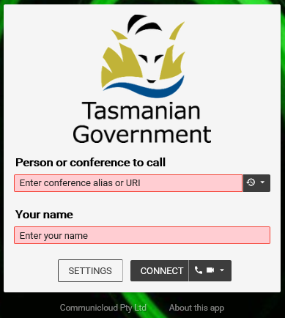
  - Alternatively, you may have been sent a link that directs you to the main Telehealth Videoconferencing page (Telehealth Login Page) and the details of a dial number to enter separately.

Enter the “Dial Number”@inviewuc.cloud that you have been provide, your full name, and then click Connect.

- The first time you use the Telehealth Service, you will be asked to allow the use of your webcam and microphone from both Internet Browser and the Telehealth Login Page.
A pop-up message may appear in your browser, select the webcam and microphone you would like to use and click Share Selected Devices | 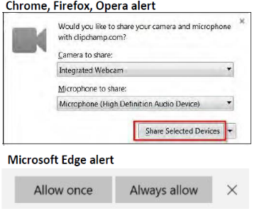 | From the Telehealth Login Page, reconfirm the webcam and microphone are correct and you should be able to see yourself and see some movement of the blue line below the microphone section when you talk. If you are happy to always use these settings, tick Don’t show me these options again, then click Start  Tip – You can click here to play a test sound | 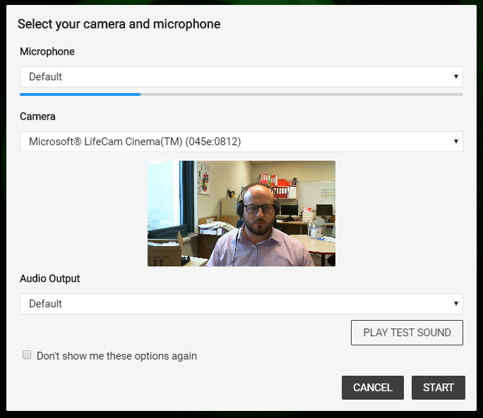

Videoconference Controls

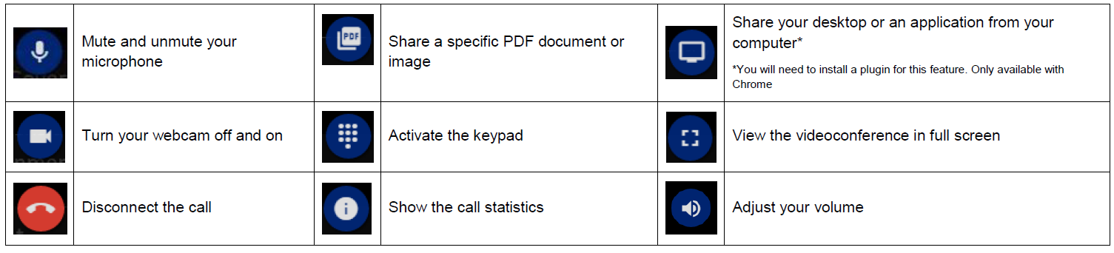

Troubleshooting

Problem | Solution
Webcam and Microphone Issues  - Error message:  Call failed: Error: Could not get access to camera/microphone. Have you allowed access? Has any other application locked the camera?  - You have no self-view image of yourself during a videoconference  - The other participants in the videoconference can’t hear or see you | Try each of these options in the following order:  - Double check your webcam is plugged in correctly.  - Check no other applications may be using your webcam such as Skype. If so, close them down.  - Check the camera status icon in your browser.  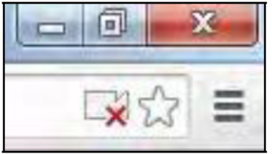  If it has a red cross then click on it and choose the option to always allow your camera and microphone. Disconnect and reconnect the call.  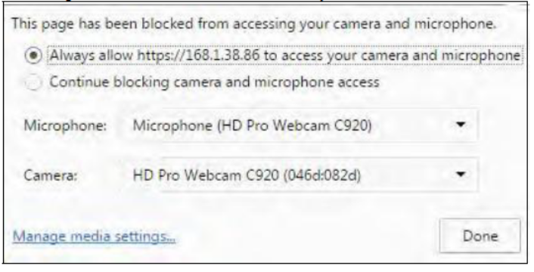  - Disconnect the call and click on the Settings button from the main screen.  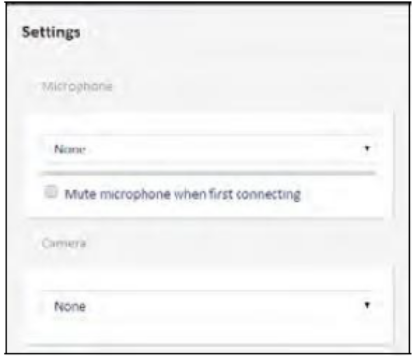  Make sure you choose the appropriate microphone and camera from the lists.

Quality and Bandwidth Issues  - Poor quality audio and video  - Call drop out | - Disconnect the call and click on the Settings button from the main screen.  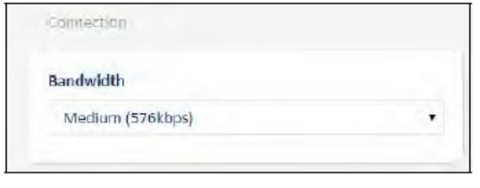  - Choose a lower bandwidth such a Low (256kbps) and reconnect the call.  - Check if any other application on your network is using the Internet and close them down.
Connection Issues  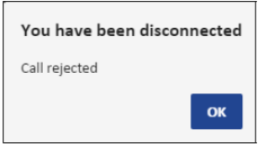 | - The dial number you have been given may be incorrect. Please contact Telehealth Tasmania on 1300 027 894 to confirm these details.
Echo and high-pitched sounds while in a videoconference | - If using computer speakers, try using a pair of headphones instead
Error Message: You are using an outdated browser | - Please upgrade your browser to the latest version. https://browsehappy.com/
General Issues | - Try using an alternative web browser.

Last updated April 2020 – Modified with permission from Queensland Health
Telehealth Tasmania - Telehealth with Chrome, Firefox, Edge, and Opera (PC, MAC, Laptops)

